**JS Advanced Exam Retake – 02 Aug 2023**

**Problem 1. Fitness Journey**

**Environment Specifics**

Please be aware that every JS environment may **behave differently** when executing code. Certain things that work in the browser are not supported in **Node.js**, which is the environment used by **Judge**.

The following actions are **NOT** supported:

* **.forEach()** with **NodeList** (returned by **querySelector()** and **querySelectorAll()**)
* **.forEach()** with **HTMLCollection** (returned by **getElementsByClassName()** and **element.children**)
* Using the **spread-operator** (**...**) to convert a **NodeList** into an array
* **append()** in Judge (use only **appendChild()**)
* **prepend()**
* **replaceWith()**
* **replaceAll()**
* **closest()**
* **replaceChildren()**
* Always turn the collection into a **JS array** (forEach, forOf, et.)

If you want to perform these operations, you may use **Array.from()** to first convert the collection into an array.

**Use the provided skeleton to solve this problem.**

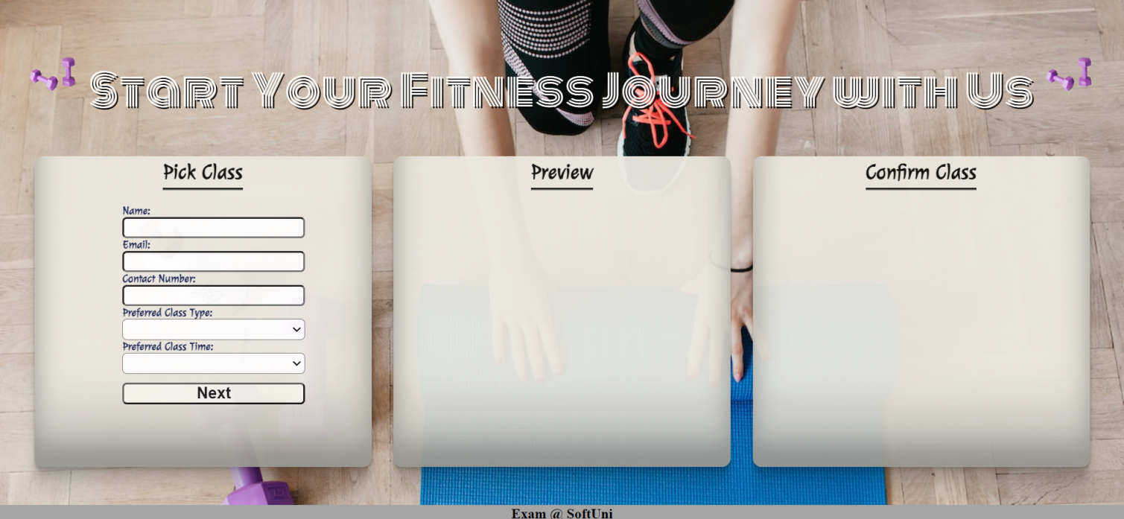**Write the missing functionality** of this user interface. The functionality is divided in the following steps:

**Your Task**

**Write the missing JavaScript code** to make the **Fitness Journey** work as expected:

All fields **(Name, Email, Contact Number, Preferred Class** and **Class Time)** are **filled with the correct input.**

* **Name, Email, Contact Number, Preferred Class** and **Class Time** are **non**-**empty** **strings.** If any of them is empty, the program should not do anything.

1. **Getting the information from the form**

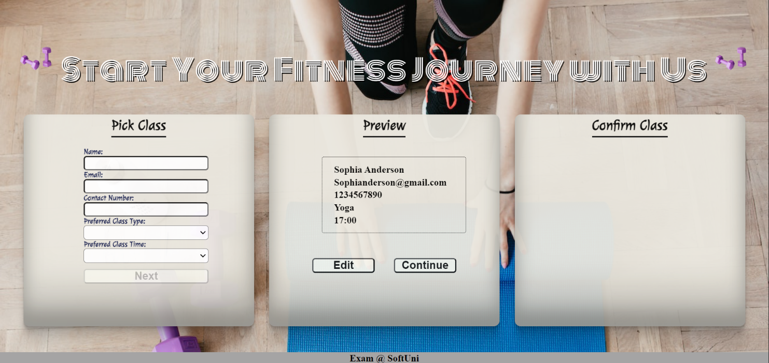

* On clicking the **["Next"]** button the information from the input fields is listed in the **"preview-section"** section. For the input fields a **list item** is **added** to the **"class-info"** unordered list.
* The text format and order for the list item should be the same as on the picture below.
* When the button is clicked, the input fields must be cleared and the **["Next"]** button must be **disabled**. At the same time the **"Edit"** and the **"Continue"** buttons must be **added**.

The HTML structure looks like this:

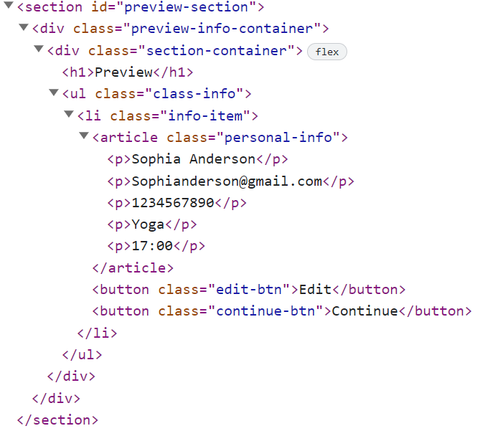

**The functionality here is the following:**

* **When the "Edit" button is clicked, all of the information is loaded in the input fields from step 1 and the ["Next"] button is enabled again.**

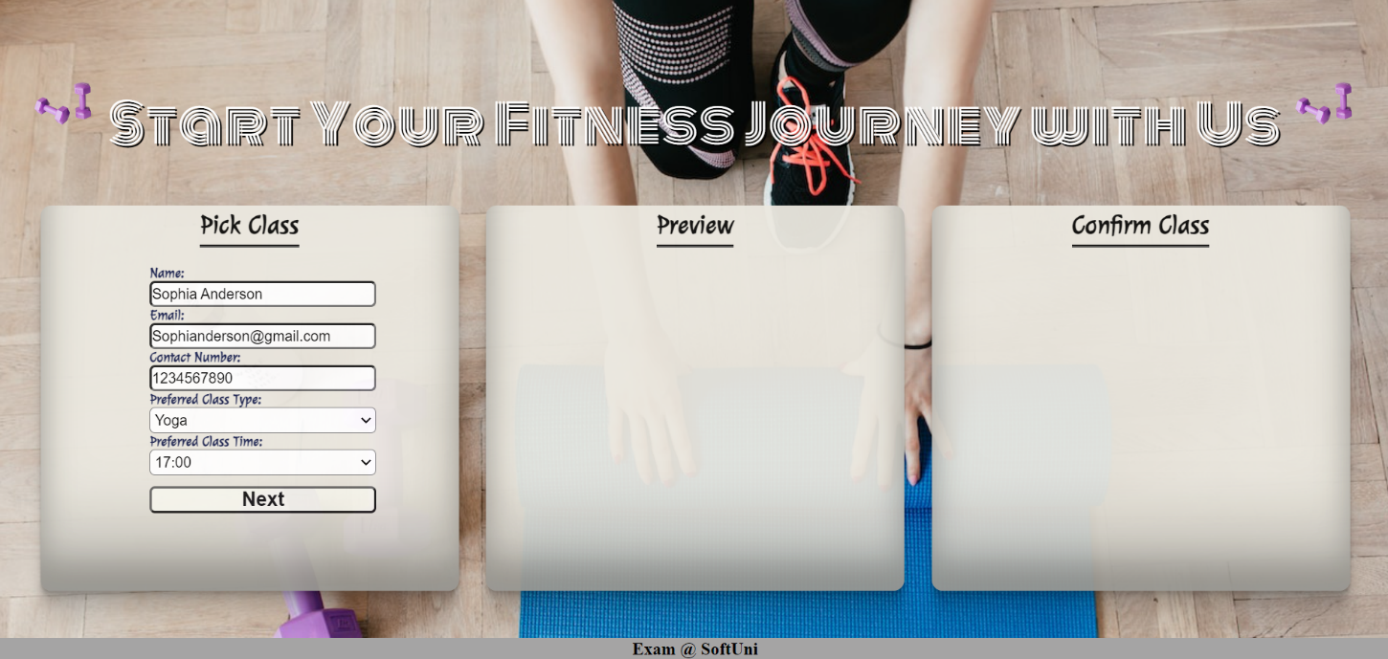

* **The list item must be removed from the "class-info" and all of the information must go back to the input fields again.**

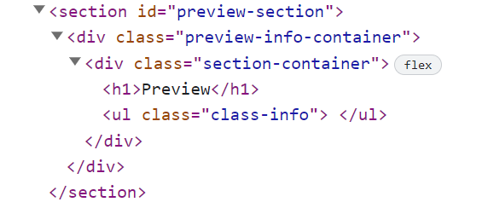

* **When the "Continue" button is clicked,** **the information from "class-info"** unordered list must be transferred to **"confirm-class"** in the **same** HTML structure**. For you, this means removing everything inside of the ul with class "class-info" and adding in "confirm-class"**, **the list item with same information and class "continue-info" , delete "Edit"** and **"Continue"** buttons and **add** new buttons **"Confirm"** and **"Cancel"** with **class "confirm-btn"** and **"cancel-btn"** .

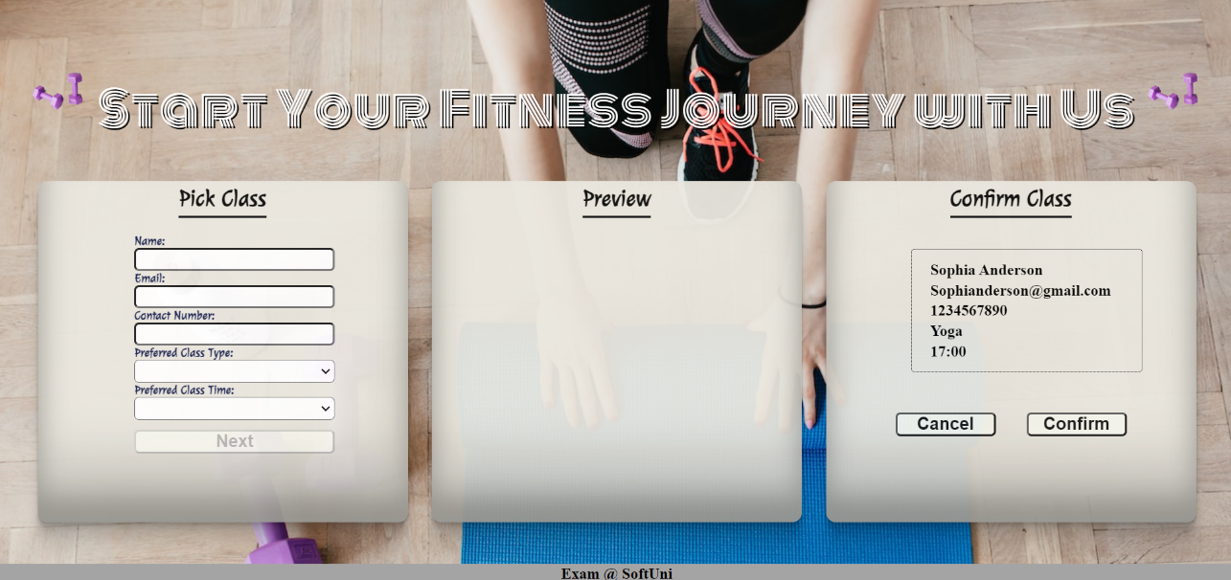

* **This is the HTML** structure **of "confirm-class"** unordered list**:**

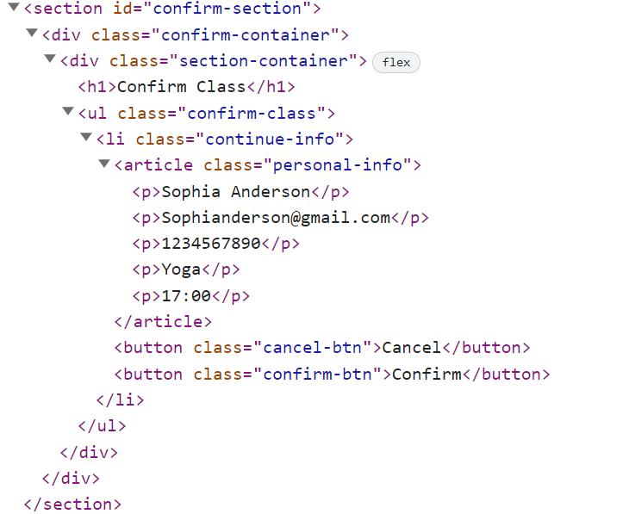

* **When the "Cancel" button is clicked,** **the list item must be removed, from the "confirm-class", the ["Next"] button is enabled again.**

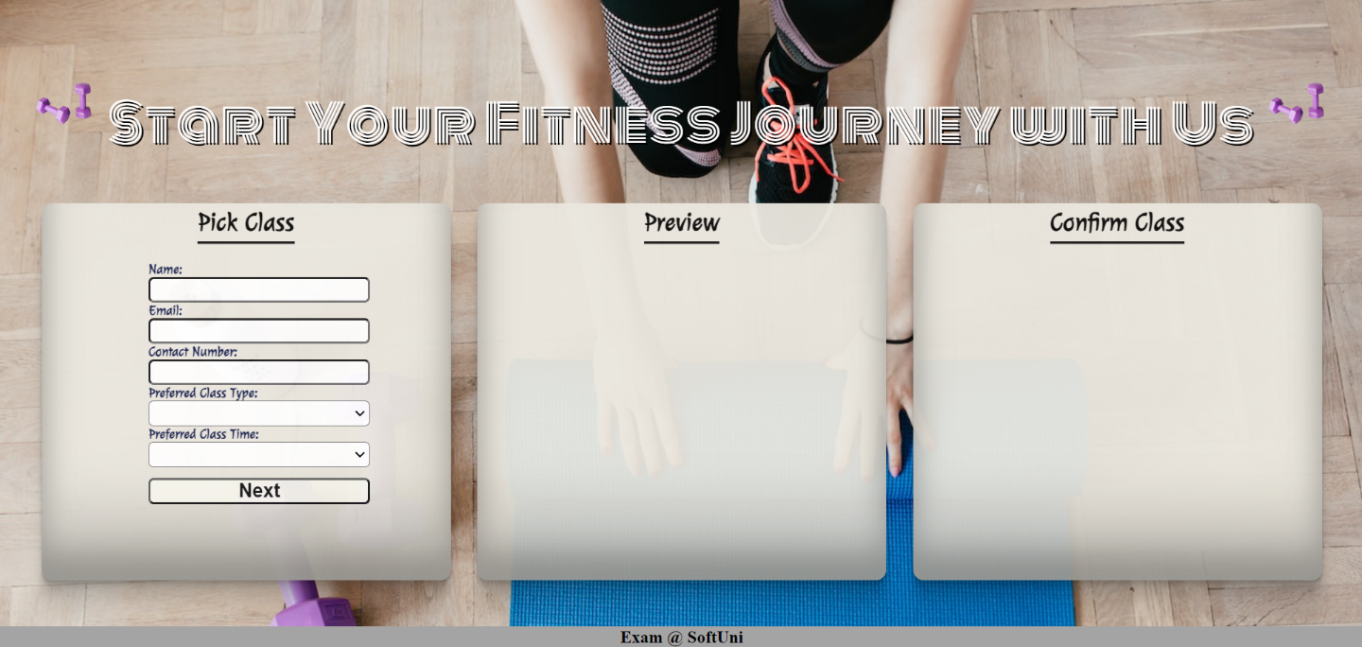

* **When the "Confirm" button is clicked,** **the <div> element with id="main" must be removed, from the body** andyoumust **add <h1>** element with id=**"thank-you"** and **text "Thank you for scheduling your appointment, we look forward to seeing you!"** and **<button>** with id=**"done-btn"** and **text "Done".**



The HTML structure looks like this:

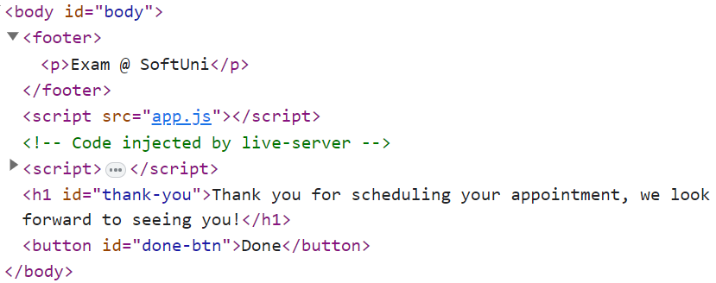

* On clicking the **["Done"]** button you must **reload** the page.

**Submission**

Submit only your **solution()** function.

*GOOD LUCK… ☺*